**File Permission Task**

**Task Description:**

Create a file with .txt extension (/home/demo.txt). Change the permission set of that file, so that any user can read it, group can read/write & owner can read/write/execute it.

**Output:-**

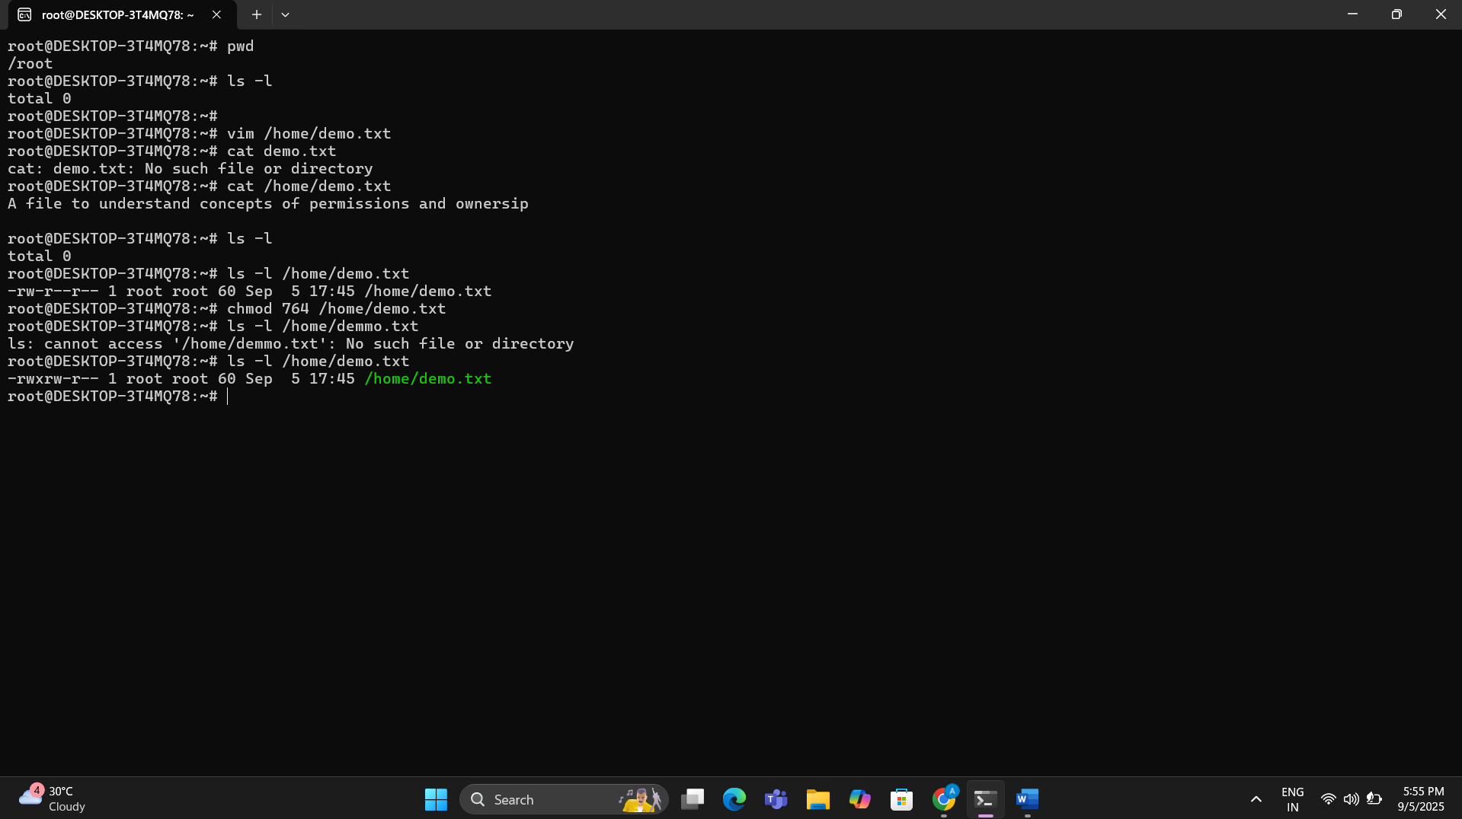

Here I have used the numeric method either we also can use the symbolic method to change the ownership for the file Owner (User), Groups and Others .

Here:-

Chmod u+rwx /home/demo.txt

chmod g+rw /home/demo.txt

chmod o+r /home/demo.txt